

EAGLE EXAMINATION BOARD
EXAMINATION 2023
INTEGRATED SECIENCE
Time Allowed: 2 HOURS 15 MINUTES
Random No. |  |  |  |  |  | Personal No.
Index No.

Pupil’s Name: ………………………………………………………..……………………
School Name: ……………………………………………………….……………………..
The paper has two sections: A and B
FOR EXAMINERS’ USE ONLY
Qn. No. | MARKS | EXRS’ NO.
1 – 10
11 – 20
21 – 30
31 – 40
41 – 43
44 – 46
47 – 49
50 – 52
53 – 55
TOTAL

- Section A has 40 short questions (40 marks)
- Section B has 15 questions (60 marks)
- Answer ALL questions. All answers to both Sections A and B must be written in the spaces provided.
- All answers must be written using a blue or black ball point pen or ink. Diagrams should be drawn in pencil.
- Unnecessary alteration of work may lead to loss of marks.
- Any handwriting that cannot be easily read may lead to loss of marks.
- Do NOT fill anything in the boxes indicated for Examiner’s use only

SECTION A (40 MARKS)
- What is another name for a worker bee in a bee hive?
……………………………………………………………………………………………………………………………...….
- Why is it important to wash hands with not only water but also soap after visiting a latrine?
………………………………………………………………………………………………………………………..………..
- Mention any one cause of short circuits.
……………………………………………………………………………………………………………………………..….
- Describe one use of bacteria that are commonly found in dead animals.
…………………………………………………………………………………………………………………………..…….
- Why is it not advisable to pour insecticides or acidic substances in latrines?
…………………………………………………………………………..………………………………………………..…..
- How can the government control spread of a cattle disease once it breaks up in an area?
………………………………………………………………………………………………………………………………..
- Describe the importance of water in our diet.
…………………………………………………………………………………………………………………………….….
- Which chemical in tobacco readily combines with hemoglobin?
……………………………………………………………………………………………………………………………….
- Why do clothes dry faster on a dry and windy day than on a cold day?
……………………………………………………………………………………………………………………………….

- How long is the gestation period of an ewe?
……………………………………………………………………………………………………………………..……..…..
- Name the name chemical burning of food in the food.
……………………………………………………………………………………………………………………………….…
- Why is there more carbon dioxide at night than during day?
……………………………………………………………………………………………………………………………….…
- How is intercropping important to a farmer who practices it?
………………………………………………………………………………………………………………………………….
- Explain why an earthworm is regarded as an invertebrate.
………………………………………………………………………………………………………………………………..…
- Name any other way the body can lose heat other than through sweating.
…………………………………………………………………………………………….……………………………….…..
- What do you understand by the term adolescence?
……………………………………………………………………………………………………………………………..…..
- What is the use of a beak to a bird?.
……………………………………………………………………………………………………………………………….…
- Identify the property of air shown in the diagram.

………………………………………………………………………………………………………………………………….
- What simple method can be used to distinguish a bad egg from a god one?
………………………………………………………………………………………………………………………………….

- Why do crawling children usually suffer from diarrhea?
………………………………………………………………………………………………………………………………….
- State one importance of vitamins to the body.
………………………………………………………………………………………………………………………………….
- Draw any one percussion instrument in the space below.

- What environmental hazard may result from poor disposal of polythene papers?
………………………………………………………………………………………………….……………..……………….
- Miria left her bicycle under the hot sun, so its tyre burst. What does this tell us about air?
……………………………………………………………………………………………….………………………..….…..
- Give the importance of breast feeding to mothers.
…………………………………………………………………………………………..……………………………..……..
- Explain what happens to the lungs in the human body when one breathes in.
………………………………………………………………………………………………………………………...........
- Apart from calcium, what other mineral is used for the proper growth of bones and teeth?
…………………………………………………………………………………………………………………………………

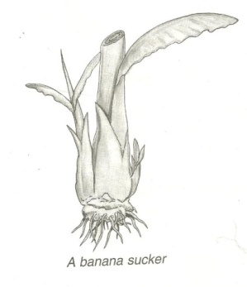
- The diagram below is of a banana plant. Use it to answer questions that follow.

X

Name the type of roots marked with letter X.
……………………………………………………………………………………………………………………….…………
- Describe any one way in which people can manage sunny weather in their environment.
…………………………………………………………………………………………………………………………..……
- Which part of the skeleton protects the reproductive organs?
………………………………………………………………………………………………………………………………..
The diagram below shows bar magnets. Study it to answer the questions that follow.

N

F
- Name pole F.
…………………………………………………………………………………………………………………..
- State one way people may contaminate food at home.
……………………………………………………………………………………………………………………………..
- Where does gaseous exchange take place in human beings?
……………………..…………………………………………………………………………………………………………
- What is the difference between a sprain and strain?
………………………………………………………………………………………………………………………………………………………………………………………………………………………………………………………………….
- The diagram below is of a torch. Use it to answer questions that follow.
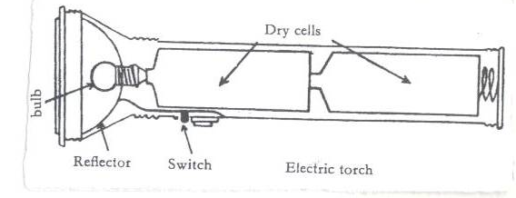
Spring
B
A
What is the function of the spring in the torch above?
…………………………………………………………………………………………………………………………….……
- State one importance of teeth during digestion.
………………………………………………………………………………………………………………….……………..
- Ryan was playing with a ball made of copper passing it through a ring. He decided to heat it, but he found he could no longer pass it through the ring. Explain what had happened?
……………………………………………………………………………………..………………….……………………..
- How can dehydration be managed in children below the age of five years.
…………………………………………………………………………………………………………………………………
- Name any one immunisable disease caused by bacteria.
…………………………………………………………………………………………………………………………………

- Identify one effect of the rotation of the earth.
………………………………………………………………………………………………………………………………….
SECTION B
- Match the following types of joints with their locations in the body correctly.
Types of joints Location in the body
Gliding joints Elbow and knee
Pivot joints Wrist and ankle
Ball and socket joints the neck
Hinge joints Shoulder and hips
- Gliding joints …………………………………………………………………………..…………..
- Pivot joints ……………………………………………………………………………………….
- Ball and socket joints ………………………………………….…….…………………………….
- Hinge joints …………………………………..………………………………..…………………..
- a) Which part of the following crops can be used for producing alcohol?
- Millet ………………………………………………………..….……………………………………..
- Cassava …………………………………………………………………………………………………..
b) Name the fungus which is used in the production of alcohol.
………………………………………………………………………………………………………………………………..
c) Apart from waragi, give any other example of an alcoholic drink.
…………………………………………………………………………………..……………………………………………

- The diagram shows the composition of air. Use it to answer the questions that follow.
A
B
D
C

- Name the gases marked with letters B and D
B ……………………………………………………………………………………………………...……………………..
D ……………………………………………………………………………………………..……………………………...
- Identify any one process that involves use of gas C.
…………………………………………………………………………………………………………………………………
- State any one way in which gas marked A is important to people.
…………………………………………..…………………………………………………………………………………..
- a) What is paddock system of grazing?
…………………………………………………………………………………..……………………………………………..
b) Identify any one other rotational system of grazing apart from the above.
………………………………………………………………..……………………………………….…………..
c) Mention any two advantages of zero of grazing.
(i) ……………………………………………………………………………………….………………..………….……..
(ii) …………………………………………………………………………………………..……………………….……..
- a) Write any one example of each of the following components of a solution.
i) Solute …………………………………………………………………………………………………..……….
ii) Solvent ……………………………………………………………………………..…………………………….
b) How can you separate a mixture of beans and stones?
……………………………………………………………………………………………………………………………..
c) Give a method of separating mixtures used when getting juice from passion fruit.
………………………………………………………………………………………….…………………………………..
- The diagram below is of a simple circuit. Use it to answer the questions that follow.
A
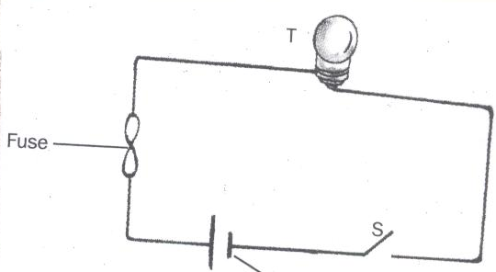
C
B
- Name the part labeled C
……………………………………………………………………………………………………………………………….
- What is the function of the part named in (a) above?
………………………………………………………………………………………………………………………………
- What is the similarity function between part C and B?
…………………………………………………………………………………….………………………………………..
- Describe one energy change that takes place at A when the circuit is completed.
…………………………………………………………………………………………………………………………..
- a) State any two roles children play in a home.
(i) ……………………………………………………………………..………………………………………….……..
(ii) ………………………………………………………………………………………….……………………………
b) Identify any two forms of child abuse in our society.
(i) ……….……………………………………………………………………………………………...………………..
(ii) ……………………………………………………………………………………………………………..………….
- a) Name the second stage of the life cycle of a locust.
………………………………………………………………………………………………………………….….………
b) State any two diseases spread by cockroaches to people.
……………………………………………………………………………………………………………....…………
c) How can you help family members to reduce cockroach infestation in a home?
……………………………………………………………………………………………………………..…………..
- Use the list of items below to answer questions that follow.
Goat, Wind, Sisal, Petroleum.
- Name any two items from the list that are renewable resources.
- ……………………………………………………………………………..….……………………………
- ……………………………………………………………………………….……………………………..
- Identify one item that is a fossil fuel.
……………………………………………………………………………………………………………………..…..
- Give one way people can use the resource that starts with letter “S” in the list above.
…………………………………………………………………………………………………………….………….

- Use the diagram below to answer the questions that follow.
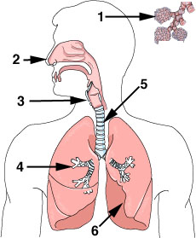
P
R
Trachea
Q
- Name the parts marked with letter P and Q
P ……………………………………………………………………………………….……………………………..…
Q …………………………………………………………….…………………….……………………..……………….
- How is part marked R adapted to its function?
…………………………………………………………………..…………………………………………………………..
- Identify one immunisable disease of the system above.
………………………………………………………………………………………………………………………………….
- a) Distinguish between a pest and a parasite.
…………………………………..……………………………………………………………………………………………..
……………………………………………………………………………………………………….………………………..
b) Mention any two pests that destroy maize in the garden.
(i) …………………………………………………………………………………………………….……………….……..
(ii) ……………………………………………………………………………………………………………………………
c) Describe any one way farmers control pests on the garden.
…………………………………………………………………………………..……………………………………………..
- a) What name is given to a mixture of two or more metals?
………………………………………………………………………………………………………….………………………
b) Give one example of a common mixture of metals?
……….…………………………………………………………………………………………………………..……………
c) Why do people use aluminum to make cooking utensils instead of silver that is a better conductor of heat?
………………………………………………………………………………………………..…………………………….
d) By what process does heat move through metallic utensils?
………………………………………………………………………………………………..…………………………….
- a) What is germination?
…………………………………………………………………………………………..……………………………………..
b) Give any two conditions necessary for germination to occur.
(i) …………………………………………………………………………………….……………………….…………….
(ii) ………………………………………………………………………………………….………………………………..
c) What type of germination does a millet grain undergo?
……………………………………………………………………………………………..………………..………………
- a) What germ causes malaria?
……………………………………………………………………………………………….…………….…………………
b) Why does the government of Uganda periodically give out free mosquito nets instead of selling them to people?
……………………………………………………………………………………………….………………………………..
c) Why would the control of malaria be more difficult than control of AIDS?
………………………………………………………………………………………………………………………………….
d) Name the world day concerned with control of diseases.
………………………………………………………………………………………………………………………………….

- a) Explain what a health parade is.
………………………………………………………………………………………………………………………………….
b) Describe any two importance of health parades in schools.
(i)…………………………………………………………………………………………………………..…………………
(ii) ..……………………………………………………………………………………………….…………………………
c) Give any one problem that may be faced by children in a school that does not hold health parades.
………………………………………………………………………………………………………………………………….

END

